ASSIGNMENT - 2

ANIKEIT SETHI(190001003)

Code: -

# 0-1 knapsack algorithm using branch and bound  
  
data_weight = [20, 40, 60, 100, 120, 10, 50]  
data_value = [100, 80, 120, 150, 200, 40, 180]  
capacity = 200  
  
values = []  
  
for i in range(len(data_value)):  
 cost = data_value[i] // data_weight[i]  
 values.append([cost, data_value[i], data_weight[i]])  
  
values.sort(reverse=True)  
  
  
data_cost = [i[0] for i in values]  
data_weight = [i[2] for i in values]  
data_value = [i[1] for i in values]  
  
  
class State(object):  
 def __init__(self, level, benefit, weight, token):  
  
 self.level = level  
 self.benefit = benefit  
 self.weight = weight  
 self.token = token  
 self.available = self.token[:self.level] + [1] * (len(data_value) - level)  
 self.ub = self.upperbound()  
  
 def upperbound(self):  
 upperbound = 0  
 weight_accumulate = 0  
 for i in range(len(data_weight)):  
 if data_weight[i] * self.available[i] <= capacity - weight_accumulate:  
 weight_accumulate += data_weight[i] * self.available[i]  
 upperbound += data_value[i] * self.available[i] # Anikeit Sethi

else:  
 upperbound += data_value[i] * (capacity - weight_accumulate) / data_weight[i] * self.available[i]  
 break  
 return upperbound  
  
 def develop(self):  
 level = self.level + 1  
 if self.weight + data_weight[self.level] <= capacity:  
 left_weight = self.weight + data_weight[self.level]  
 left_benefit = self.benefit + data_value[self.level]  
 left_token = self.token[:self.level] + [1] + self.token[self.level + 1:]  
 left_child = State(level, left_benefit, left_weight, left_token)  
 else:  
 left_child = None  
  
 right_child = State(level, self.benefit, self.weight, self.token)  
 if left_child is not None:  
 return [left_child, right_child]  
 else:  
 return [right_child]  
  
  
Root = State(0, 0, 0, [0] * len(data_value))  
waiting_States = []  
current_state = Root  
while current_state.level < len(data_value):  
 waiting_States.extend(current_state.develop())  
 waiting_States.sort(key=lambda x: x.ub)  
 current_state = waiting_States.pop()  
best_solution = current_state  
  
print("Value :", data_value)  
print("Weight :", data_weight)  
print("Capacity :", capacity)  
  
print("Total Max Value: ", best_solution.benefit)

Output: -

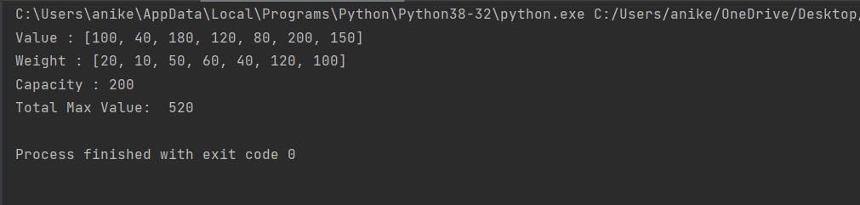

Graph: -

